附件1：
校外用户网上缴费流程图
1、登录网址: http://pay.nju.edu.cn
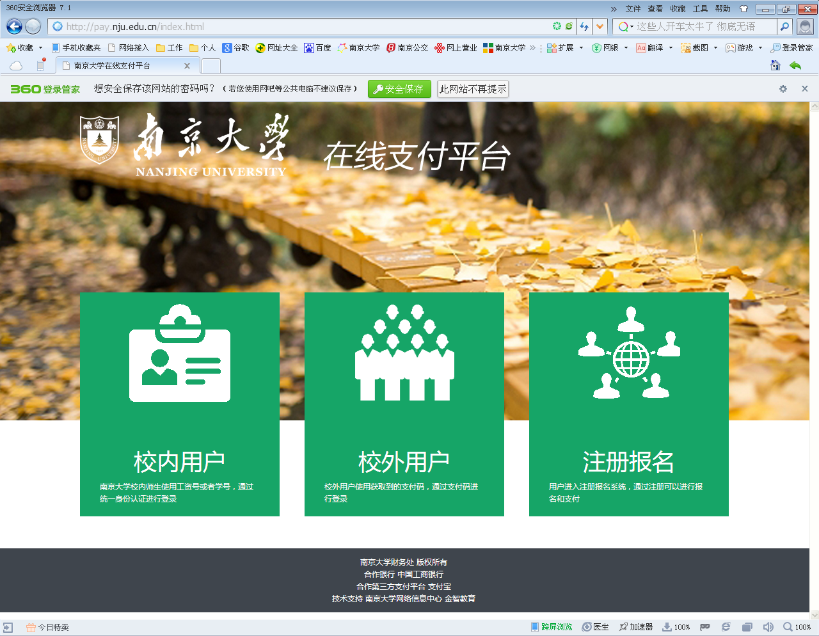

2、点中间“校外用户”。

3、输入自己的16位包含字母和数字的支付码（密码）登录后，即可通过任一家银行网银支付，支付码（密码）如下表：
项目名称 | 考试编号 | 姓名 | 收费金额 | 密码
2023非全日制研究生复试费 | 102843211504920 | 蔡问号 | ¥80.00 | F0EA78B2F5A6CEDA
2023非全日制研究生复试费 | 102843211504940 | 陈烨锴 | ¥80.00 | 405AD9C05D85C943
2023非全日制研究生复试费 | 102843211504944 | 成明阳 | ¥80.00 | 94EC93E8329E2BC2
2023非全日制研究生复试费 | 102843211504947 | 戴博文 | ¥80.00 | D9AE79161DED1076
2023非全日制研究生复试费 | 102843211504949 | 戴宇翔 | ¥80.00 | 7A45FB0880D94687
2023非全日制研究生复试费 | 102843211504950 | 邓雪薇 | ¥80.00 | 1E48A538985DD1D6
2023非全日制研究生复试费 | 102843211504956 | 董晶 | ¥80.00 | 92C9639AA9F6D0D5
2023非全日制研究生复试费 | 102843211504961 | 范尔冬 | ¥80.00 | 091BB81BC44D270D
2023非全日制研究生复试费 | 102843211504962 | 方正 | ¥80.00 | CDA60E8DB87A3122
2023非全日制研究生复试费 | 102843211504965 | 冯立君 | ¥80.00 | 444605B14BD792A5
2023非全日制研究生复试费 | 102843211504967 | 冯一 | ¥80.00 | A5D176398B41E93A
2023非全日制研究生复试费 | 102843211504974 | 葛中秋 | ¥80.00 | 5B36A3DC3620E249
2023非全日制研究生复试费 | 102843211504983 | 郭明月 | ¥80.00 | 3C38BF2BFEC03151
2023非全日制研究生复试费 | 102843211504998 | 胡杨 | ¥80.00 | 72ED5C286CE451AC
2023非全日制研究生复试费 | 102843211505000 | 黄慧蓉 | ¥80.00 | 8CCE2FA5F9F49FA0
2023非全日制研究生复试费 | 102843211505005 | 黄燕 | ¥80.00 | 8A6643F44451D6B5
2023非全日制研究生复试费 | 102843211505012 | 江禹轩 | ¥80.00 | 6C92537EE43B32A5
2023非全日制研究生复试费 | 102843211505018 | 焦明贝 | ¥80.00 | BC0EF130B051032F
2023非全日制研究生复试费 | 102843211505027 | 李碧 | ¥80.00 | 37DE36BE9D983572
2023非全日制研究生复试费 | 102843211505030 | 李洁 | ¥80.00 | 4BA216B461CA5B88
2023非全日制研究生复试费 | 102843211505045 | 李子逸 | ¥80.00 | 22864D6D549ED942
2023非全日制研究生复试费 | 102843211505046 | 梁彩平 | ¥80.00 | 36AC00C6696A14A2
2023非全日制研究生复试费 | 102843211505049 | 林泊宇 | ¥80.00 | D8E4D326EA5AF7D1
2023非全日制研究生复试费 | 102843211505050 | 林东奇 | ¥80.00 | 01F91BBEB0E59673
2023非全日制研究生复试费 | 102843211505054 | 刘弘扬 | ¥80.00 | D4DEACA9F3F610FE
2023非全日制研究生复试费 | 102843211505061 | 刘宁 | ¥80.00 | 76DDE039E3C6B3F3
2023非全日制研究生复试费 | 102843211505062 | 刘倩文 | ¥80.00 | ED78660C3E95AFFE
2023非全日制研究生复试费 | 102843211505068 | 刘艺霖 | ¥80.00 | FE28B3C88CE02232
2023非全日制研究生复试费 | 102843211505071 | 柳栋淼 | ¥80.00 | F3424ADA805B4F4A
2023非全日制研究生复试费 | 102843211505079 | 陆启亚 | ¥80.00 | 7D71DF0A3CDEFF78
2023非全日制研究生复试费 | 102843211505081 | 罗林丽 | ¥80.00 | 716C2430645FE6D2
2023非全日制研究生复试费 | 102843211505084 | 吕天瑞 | ¥80.00 | 2D7C93ABD7F54E8D
2023非全日制研究生复试费 | 102843211505087 | 马万正 | ¥80.00 | 8604F6538FD586F8
2023非全日制研究生复试费 | 102843211505092 | 缪晨 | ¥80.00 | 8626C12EBD859705
2023非全日制研究生复试费 | 102843211505099 | 裴雅杰 | ¥80.00 | E91BDE8E7E5754D5
2023非全日制研究生复试费 | 102843211505103 | 钱立 | ¥80.00 | 2F23F5B782F6412F
2023非全日制研究生复试费 | 102843211505104 | 钱中阳 | ¥80.00 | 7EC8902A5D7CF177
2023非全日制研究生复试费 | 102843211505107 | 邱祎臻 | ¥80.00 | 2A02181ED4F9F6FF
2023非全日制研究生复试费 | 102843211505117 | 沈飞飞 | ¥80.00 | 84A76608161908EA
2023非全日制研究生复试费 | 102843211505118 | 沈家敏 | ¥80.00 | 82D89895F3BB8B4A
2023非全日制研究生复试费 | 102843211505119 | 沈林江 | ¥80.00 | 971726E3F0B58A26
2023非全日制研究生复试费 | 102843211505121 | 沈小琰 | ¥80.00 | 222B719555F469B1
2023非全日制研究生复试费 | 102843211505132 | 孙鹏 | ¥80.00 | 6818C16DE19A376B
2023非全日制研究生复试费 | 102843211505133 | 孙如海 | ¥80.00 | B2257023EA4B076D
2023非全日制研究生复试费 | 102843211505134 | 孙硕锴 | ¥80.00 | 4612BC600339E2B1
2023非全日制研究生复试费 | 102843211505135 | 孙小燕 | ¥80.00 | 6F075231F5980A61
2023非全日制研究生复试费 | 102843211505136 | 孙晓斌 | ¥80.00 | 96E1871D8BF3217B
2023非全日制研究生复试费 | 102843211505139 | 孙一帆 | ¥80.00 | 7F9E80EF69E14903
2023非全日制研究生复试费 | 102843211505150 | 汪淑洁 | ¥80.00 | B613C9960978B70B
2023非全日制研究生复试费 | 102843211505156 | 王海月 | ¥80.00 | 038D1C10C2B9BA48
2023非全日制研究生复试费 | 102843211505162 | 王菊 | ¥80.00 | EAED140A1DFAA9B4
2023非全日制研究生复试费 | 102843211505165 | 王萌 | ¥80.00 | 8C652201082F8C75
2023非全日制研究生复试费 | 102843211505166 | 王澎 | ¥80.00 | 3A71AB7139BE094F
2023非全日制研究生复试费 | 102843211505169 | 王彦 | ¥80.00 | F72BE59634634672
2023非全日制研究生复试费 | 102843211505176 | 王子豪 | ¥80.00 | 2747181ABAB145F3
2023非全日制研究生复试费 | 102843211505191 | 吴昱东 | ¥80.00 | F041062A34734769
2023非全日制研究生复试费 | 102843211505192 | 吴正亚 | ¥80.00 | E1558694532DF3CC
2023非全日制研究生复试费 | 102843211505199 | 谢晨才 | ¥80.00 | 892E8CAB7076D795
2023非全日制研究生复试费 | 102843211505210 | 徐昊然 | ¥80.00 | 13BA844D0EF93E72
2023非全日制研究生复试费 | 102843211505216 | 徐炀 | ¥80.00 | B187F90FDF667B09
2023非全日制研究生复试费 | 102843211505239 | 杨威 | ¥80.00 | 868C4D2A023D1DE1
2023非全日制研究生复试费 | 102843211505243 | 姚磊 | ¥80.00 | 980AD795B50357E2
2023非全日制研究生复试费 | 102843211505244 | 叶海霞 | ¥80.00 | 656D02364DC492B1
2023非全日制研究生复试费 | 102843211505250 | 尤文哲 | ¥80.00 | 32C434B4148FBBD1
2023非全日制研究生复试费 | 102843211505252 | 余辉 | ¥80.00 | D361FF307E651A3D
2023非全日制研究生复试费 | 102843211505260 | 臧广梅 | ¥80.00 | 2F28751BC9CCF2EA
2023非全日制研究生复试费 | 102843211505261 | 翟峻鹏 | ¥80.00 | D2AFB80690225D34
2023非全日制研究生复试费 | 102843211505263 | 张琛 | ¥80.00 | 064AEF2B94270E10
2023非全日制研究生复试费 | 102843211505264 | 张成 | ¥80.00 | 75E8EDED0E5849A0
2023非全日制研究生复试费 | 102843211505265 | 张恒 | ¥80.00 | F73CB4FAE75C2805
2023非全日制研究生复试费 | 102843211505271 | 张宁 | ¥80.00 | AE7235E5B433D17F
2023非全日制研究生复试费 | 102843211505276 | 张思聪 | ¥80.00 | EEBB74D27A847EA8
2023非全日制研究生复试费 | 102843211505277 | 张思敏 | ¥80.00 | D8AD2F72437F8437
2023非全日制研究生复试费 | 102843211505279 | 张腾 | ¥80.00 | B044307F7DB62498
2023非全日制研究生复试费 | 102843211505280 | 张铁监 | ¥80.00 | 2FDB5BC67165DF00
2023非全日制研究生复试费 | 102843211505282 | 张文喆 | ¥80.00 | 12144F638182AB77
2023非全日制研究生复试费 | 102843211505283 | 张霄 | ¥80.00 | 600482B0E855C448
2023非全日制研究生复试费 | 102843211505289 | 赵立梅 | ¥80.00 | F653506191A1E59F
2023非全日制研究生复试费 | 102843211505294 | 赵泽方 | ¥80.00 | 5544D1AA83246642
2023非全日制研究生复试费 | 102843211505297 | 郑俊锋 | ¥80.00 | 2B9F3CE5BFCB7542
2023非全日制研究生复试费 | 102843211505310 | 朱耿生 | ¥80.00 | 619B8855A448F884
2023非全日制研究生复试费 | 102843211505311 | 朱浩宇 | ¥80.00 | 5B929BCF50BA76D8
2023非全日制研究生复试费 | 102843211505317 | 朱源暾 | ¥80.00 | C0B6E7F9A2C6E450
2023非全日制研究生复试费 | 102843211505320 | 庄安 | ¥80.00 | 14B4A88D5D941F58
2023非全日制研究生复试费 | 102843211519391 | 卜运奇 | ¥80.00 | E9F9CDE186DAA470
2023非全日制研究生复试费 | 102843211519394 | 曹子健 | ¥80.00 | 40D99AD6C5869102
2023非全日制研究生复试费 | 102843211519395 | 晁苏洋 | ¥80.00 | BC9EB97B5BD98DE1
2023非全日制研究生复试费 | 102843211519398 | 陈国帅 | ¥80.00 | 329666D9D53F7DA4
2023非全日制研究生复试费 | 102843211519407 | 陈永旭 | ¥80.00 | 4110C7D98185EDFD
2023非全日制研究生复试费 | 102843211519408 | 陈有玉 | ¥80.00 | AF6EB4ED965D8BC2
2023非全日制研究生复试费 | 102843211519414 | 程宏明 | ¥80.00 | AFAF7F0AFF46F4C0
2023非全日制研究生复试费 | 102843211519418 | 笪洋 | ¥80.00 | BBE77FD3224FEF06
2023非全日制研究生复试费 | 102843211519419 | 戴川 | ¥80.00 | 617C66378301CD9B
2023非全日制研究生复试费 | 102843211519433 | 费昀屾 | ¥80.00 | EC59E3CC4CBAA207
2023非全日制研究生复试费 | 102843211519445 | 顾成星 | ¥80.00 | DEE955857CE83660
2023非全日制研究生复试费 | 102843211519448 | 顾玲华 | ¥80.00 | CF2FF951D454508A
2023非全日制研究生复试费 | 102843211519469 | 胡杰 | ¥80.00 | 1B8AFCDE59BF176F
2023非全日制研究生复试费 | 102843211519476 | 黄强 | ¥80.00 | AB35CB485FF3CB66
2023非全日制研究生复试费 | 102843211519480 | 黄宇 | ¥80.00 | A8EEEB5B3447B843
2023非全日制研究生复试费 | 102843211519481 | 季杰 | ¥80.00 | 158450CA7290CDEF
2023非全日制研究生复试费 | 102843211519482 | 姜建华 | ¥80.00 | 856C34E6D798546E
2023非全日制研究生复试费 | 102843211519485 | 姜宇晴 | ¥80.00 | 65D19B7E7CD0503A
2023非全日制研究生复试费 | 102843211519486 | 蒋超一 | ¥80.00 | E73B93442653D335
2023非全日制研究生复试费 | 102843211519490 | 金辉 | ¥80.00 | 8B9B648A466DA8E8
2023非全日制研究生复试费 | 102843211519499 | 孔锦鹏 | ¥80.00 | 6001AB2BA0C49EC9
2023非全日制研究生复试费 | 102843211519541 | 刘云杰 | ¥80.00 | 07F2237C521F47B3
2023非全日制研究生复试费 | 102843211519544 | 娄伟 | ¥80.00 | 746D4D56459E8C51
2023非全日制研究生复试费 | 102843211519547 | 陆韧群 | ¥80.00 | 759B01ACE4BFAC42
2023非全日制研究生复试费 | 102843211519549 | 罗龙 | ¥80.00 | 3A6E43012F346E4B
2023非全日制研究生复试费 | 102843211519553 | 马良麟 | ¥80.00 | EA2BDA2E1CA22FE3
2023非全日制研究生复试费 | 102843211519555 | 马文杰 | ¥80.00 | 0A602575AB3E8AC1
2023非全日制研究生复试费 | 102843211519557 | 马晔晖 | ¥80.00 | 64832DEA79BCBD20
2023非全日制研究生复试费 | 102843211519563 | 欧阳斌 | ¥80.00 | 07ED0FEB3278B760
2023非全日制研究生复试费 | 102843211519568 | 骈旭 | ¥80.00 | D6A91FCD3EC7FA2E
2023非全日制研究生复试费 | 102843211519572 | 钱程 | ¥80.00 | 33A98009F8C710EE
2023非全日制研究生复试费 | 102843211519573 | 钱林 | ¥80.00 | BBDE35FE76E44CF1
2023非全日制研究生复试费 | 102843211519576 | 邱智晖 | ¥80.00 | 44E590022E8BD124
2023非全日制研究生复试费 | 102843211519583 | 沈飞飞 | ¥80.00 | 95225A286B1A9761
2023非全日制研究生复试费 | 102843211519585 | 沈于蓝 | ¥80.00 | A0C9BACDD44008C4
2023非全日制研究生复试费 | 102843211519588 | 石含璧 | ¥80.00 | 9E342D938EDF94DB
2023非全日制研究生复试费 | 102843211519591 | 史颖超 | ¥80.00 | 9B0608CC5C8083AD
2023非全日制研究生复试费 | 102843211519594 | 树大勇 | ¥80.00 | 451A88D9B6CBF8CE
2023非全日制研究生复试费 | 102843211519602 | 孙杰 | ¥80.00 | 0C613589DD671E8F
2023非全日制研究生复试费 | 102843211519603 | 孙珂 | ¥80.00 | 403333097BA9E66B
2023非全日制研究生复试费 | 102843211519604 | 孙亮亮 | ¥80.00 | FD7512D74CA4BC92
2023非全日制研究生复试费 | 102843211519606 | 孙盼 | ¥80.00 | FB580C7ACC8EB078
2023非全日制研究生复试费 | 102843211519615 | 汪丽娟 | ¥80.00 | E193F50EB4B3CBD8
2023非全日制研究生复试费 | 102843211519618 | 王波 | ¥80.00 | B760D131109777FE
2023非全日制研究生复试费 | 102843211519624 | 王华鹏 | ¥80.00 | AEBB276F42D5F113
2023非全日制研究生复试费 | 102843211519625 | 王金强 | ¥80.00 | A08F41EF0A49E7EC
2023非全日制研究生复试费 | 102843211519640 | 王一专 | ¥80.00 | CBDC361BBC462559
2023非全日制研究生复试费 | 102843211519647 | 文静 | ¥80.00 | 6A6A458F77B55BFB
2023非全日制研究生复试费 | 102843211519656 | 吴伊诚 | ¥80.00 | EA2837B4E334BE91
2023非全日制研究生复试费 | 102843211519657 | 吴勇政 | ¥80.00 | EC9415A7C2A6B126
2023非全日制研究生复试费 | 102843211519662 | 肖蓉 | ¥80.00 | D26C51FCCE4894D5
2023非全日制研究生复试费 | 102843211519667 | 熊维艳 | ¥80.00 | 1BA3D7F1C526876E
2023非全日制研究生复试费 | 102843211519670 | 徐佳维 | ¥80.00 | 123B03B5DB7A078A
2023非全日制研究生复试费 | 102843211519672 | 徐冉 | ¥80.00 | BA1774FB62143507
2023非全日制研究生复试费 | 102843211519673 | 徐天凌 | ¥80.00 | A97FD04581F73C9C
2023非全日制研究生复试费 | 102843211519677 | 许建 | ¥80.00 | 7CD291385258D3C1
2023非全日制研究生复试费 | 102843211519680 | 严晓琪 | ¥80.00 | A49243FA7C1D051E
2023非全日制研究生复试费 | 102843211519682 | 杨帆 | ¥80.00 | 1AD040B30A1BD363
2023非全日制研究生复试费 | 102843211519685 | 杨飞 | ¥80.00 | 3A1973D81B6C5825
2023非全日制研究生复试费 | 102843211519686 | 杨航 | ¥80.00 | 7B90E5C77D97E4C0
2023非全日制研究生复试费 | 102843211519688 | 杨可 | ¥80.00 | 8BEE80CE7570F9A1
2023非全日制研究生复试费 | 102843211519689 | 杨柳 | ¥80.00 | 8EFB5F1F68826924
2023非全日制研究生复试费 | 102843211519691 | 杨天民 | ¥80.00 | 985FD0A51EF2163D
2023非全日制研究生复试费 | 102843211519692 | 杨夕蕊 | ¥80.00 | 7187B8BD3EFF9D76
2023非全日制研究生复试费 | 102843211519699 | 袁筱洁 | ¥80.00 | 131F73C4BAB754EB
2023非全日制研究生复试费 | 102843211519700 | 岳婷婷 | ¥80.00 | 9E59D4447C2675C9
2023非全日制研究生复试费 | 102843211519716 | 张翔 | ¥80.00 | 4EA21ACF0FF51057
2023非全日制研究生复试费 | 102843211519724 | 张智慧 | ¥80.00 | AB10612F6B41F10B
2023非全日制研究生复试费 | 102843211519731 | 赵丽萍 | ¥80.00 | 59D3B165C9ECB3A2
2023非全日制研究生复试费 | 102843211519734 | 赵之瑜 | ¥80.00 | CA7195E4522E0A87
2023非全日制研究生复试费 | 102843211519761 | 庄珂 | ¥80.00 | 0760109BB8CAA06A
2023非全日制研究生复试费 | 102843211519764 | 左雨凡 | ¥80.00 | 193E32CDAE8F579F

