附件1：
校外用户网上缴费流程图
1、登录网址: http://pay.nju.edu.cn
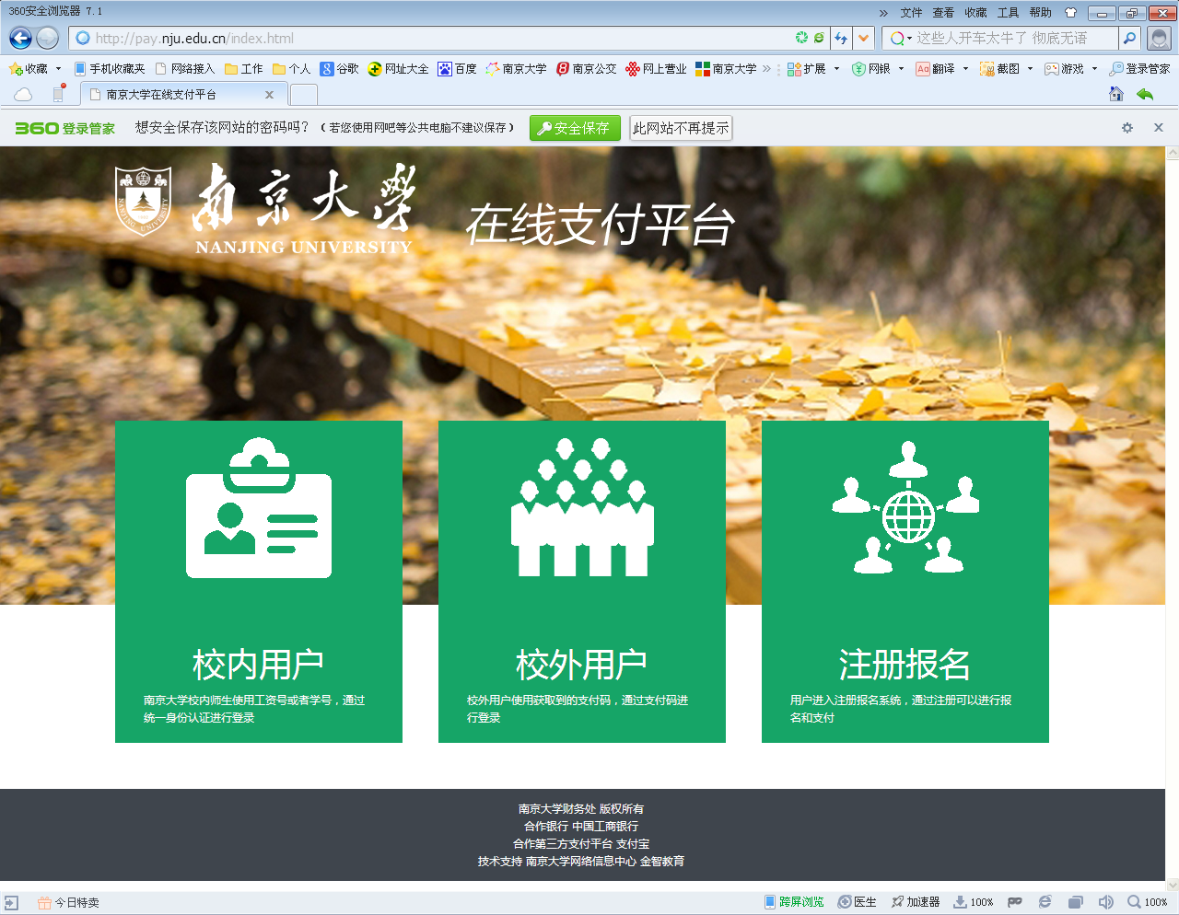

2、点中间“校外用户”。
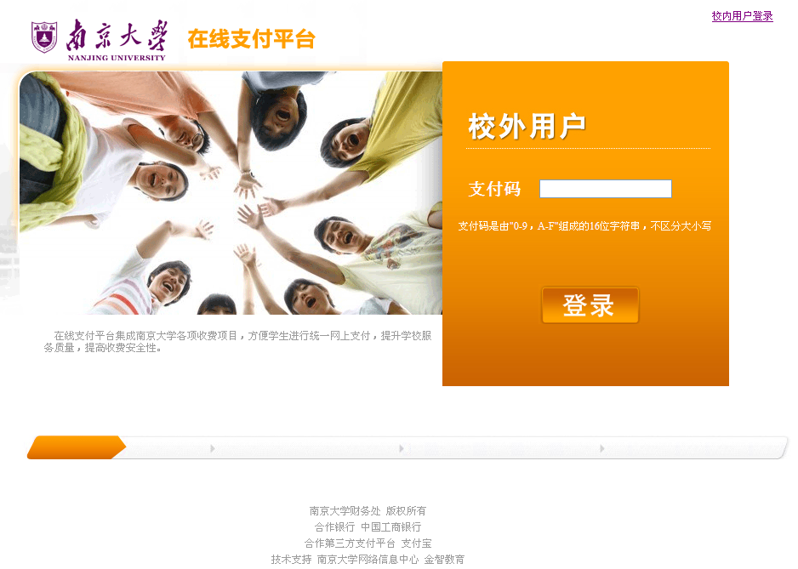
3、输入自己的16位包含字母和数字的支付码（密码）登录后，即可通过任一家银行网银支付，支付码（密码）如下表：

项目名称 | 人员编号 | 人员姓名 | 收费金额 | 密码
2021MEM复试费 | 102841211505556 | 陈帆 | ￥80.00 | 01CFCA7AF8B46FB2
2021MEM复试费 | 102841211505561 | 陈丽娜 | ￥80.00 | 97829EFD449972BA
2021MEM复试费 | 102841211505564 | 陈诺 | ￥80.00 | CEDF2A0AC9DFC1BE
2021MEM复试费 | 102841211505570 | 陈欣妤 | ￥80.00 | D0A4907D71DD70E3
2021MEM复试费 | 102841211505578 | 仇宏坤 | ￥80.00 | D3E8EC97E249722C
2021MEM复试费 | 102841211505580 | 褚庆革 | ￥80.00 | CBCEF74116951C76
2021MEM复试费 | 102841211505581 | 褚天舒 | ￥80.00 | 11FED6B2C443E559
2021MEM复试费 | 102841211505583 | 崔成韵 | ￥80.00 | A438636FC91982FA
2021MEM复试费 | 102841211505584 | 崔婷婷 | ￥80.00 | 12808414C05B85A4
2021MEM复试费 | 102841211505590 | 邓庆远 | ￥80.00 | 29C7526D1FBA4164
2021MEM复试费 | 102841211505593 | 丁绍胜 | ￥80.00 | 8888A3109402BB1F
2021MEM复试费 | 102841211505599 | 樊帅 | ￥80.00 | 6CEA68922BA54BBD
2021MEM复试费 | 102841211505602 | 范娟娟 | ￥80.00 | 443808DF3CA76CAF
2021MEM复试费 | 102841211505605 | 方文 | ￥80.00 | 736E4F8A7861D945
2021MEM复试费 | 102841211505607 | 冯军 | ￥80.00 | C07647A24E9A9A3D
2021MEM复试费 | 102841211505613 | 高凯歌 | ￥80.00 | 47E1F54379A0CB34
2021MEM复试费 | 102841211505616 | 高鹏 | ￥80.00 | 67848707DB57C490
2021MEM复试费 | 102841211505617 | 高雅 | ￥80.00 | 0056F82D043A92B6
2021MEM复试费 | 102841211505622 | 谷毅 | ￥80.00 | 70B4E510784E9E40
2021MEM复试费 | 102841211505625 | 顾克 | ￥80.00 | 332462CAA49AD7F0
2021MEM复试费 | 102841211505626 | 顾铭 | ￥80.00 | 769CF57359FE3745
2021MEM复试费 | 102841211505632 | 何浩裕 | ￥80.00 | 2C421FEB9BC89910
2021MEM复试费 | 102841211505639 | 黄旭宇 | ￥80.00 | 88D8578C28FE5506
2021MEM复试费 | 102841211505640 | 黄学飞 | ￥80.00 | 056A4125581EF13C
2021MEM复试费 | 102841211505643 | 季陈铮 | ￥80.00 | 91735AE2089F3031
2021MEM复试费 | 102841211505650 | 蒋立奇 | ￥80.00 | 332D01EC8892FAA6
2021MEM复试费 | 102841211505652 | 蒋乾元 | ￥80.00 | 457A9C27A752AE74
2021MEM复试费 | 102841211505655 | 焦玲 | ￥80.00 | 477515716C031547
2021MEM复试费 | 102841211505666 | 李昊昕 | ￥80.00 | EDF2F66A45CBAAAA
2021MEM复试费 | 102841211505667 | 李浩源 | ￥80.00 | C60D7274C1BC940F
2021MEM复试费 | 102841211505669 | 李科兴 | ￥80.00 | 311827A8DC42291A
2021MEM复试费 | 102841211505674 | 李庆之 | ￥80.00 | 56F825431D225209
2021MEM复试费 | 102841211505678 | 李颂 | ￥80.00 | 01C99B3AE64C461D
2021MEM复试费 | 102841211505680 | 李欣 | ￥80.00 | A0BBDC3478D84CB8
2021MEM复试费 | 102841211505681 | 李星辰 | ￥80.00 | 2581857947A0D221
2021MEM复试费 | 102841211505682 | 李行 | ￥80.00 | 1BDF79A50A9CC211
2021MEM复试费 | 102841211505683 | 李轩 | ￥80.00 | DE166B9C7498951E
2021MEM复试费 | 102841211505686 | 李雨乔 | ￥80.00 | DBB2C742523B9913
2021MEM复试费 | 102841211505688 | 李卓成 | ￥80.00 | FDEF233D14070085
2021MEM复试费 | 102841211505690 | 梁清远 | ￥80.00 | D282053B436D4C90
2021MEM复试费 | 102841211505694 | 林坡 | ￥80.00 | 77F829DB815F7B3C
2021MEM复试费 | 102841211505699 | 刘坤 | ￥80.00 | 0B2B4F2DC70BC59A
2021MEM复试费 | 102841211505706 | 刘跃龙 | ￥80.00 | CA3232628B475AD8
2021MEM复试费 | 102841211505719 | 罗惠珍 | ￥80.00 | 38774D74C22F0B35
2021MEM复试费 | 102841211505720 | 罗文 | ￥80.00 | 03C9FCA99CD6E215
2021MEM复试费 | 102841211505726 | 闵寒 | ￥80.00 | 2EAD9A1492DA813C
2021MEM复试费 | 102841211505728 | 穆荣生 | ￥80.00 | 859D17EC029E8BA6
2021MEM复试费 | 102841211505731 | 潘非凡 | ￥80.00 | 0220524B04BF30C9
2021MEM复试费 | 102841211505733 | 潘铮 | ￥80.00 | C934577046E66614
2021MEM复试费 | 102841211505740 | 秦昕彤 | ￥80.00 | DA1161F2D216CEB3
2021MEM复试费 | 102841211505743 | 邱添 | ￥80.00 | 72565900965BC57D
2021MEM复试费 | 102841211505744 | 任汲源 | ￥80.00 | B681BA02E86CA4D7
2021MEM复试费 | 102841211505755 | 施志晖 | ￥80.00 | 5D014A7A762734FA
2021MEM复试费 | 102841211505764 | 宋晴晴 | ￥80.00 | EF5CC8717132A482
2021MEM复试费 | 102841211505767 | 苏剑阳 | ￥80.00 | A96C57A7CCC8344C
2021MEM复试费 | 102841211505772 | 孙学勇 | ￥80.00 | 125AC8793FF521A7
2021MEM复试费 | 102841211505773 | 谭恩龙 | ￥80.00 | 8EA75C5C42B2A71C
2021MEM复试费 | 102841211505776 | 唐斌 | ￥80.00 | 41365CF6A46AC1D3
2021MEM复试费 | 102841211505781 | 田甜 | ￥80.00 | 2CEB3C5FE6ED0C69
2021MEM复试费 | 102841211505783 | 屠昊男 | ￥80.00 | CFD02B1D803CA931
2021MEM复试费 | 102841211505784 | 万唯 | ￥80.00 | 019AB0DC8DC450D6
2021MEM复试费 | 102841211505787 | 王博然 | ￥80.00 | E782E3A7A8830F63
2021MEM复试费 | 102841211505795 | 王嘉 | ￥80.00 | 14A7A8335EAC7EB1
2021MEM复试费 | 102841211505797 | 王静 | ￥80.00 | 352EDB74FB482882
2021MEM复试费 | 102841211505798 | 王侃 | ￥80.00 | 395127A66FCFBAF0
2021MEM复试费 | 102841211505801 | 王清峰 | ￥80.00 | 50153D46E6D66BDF
2021MEM复试费 | 102841211505802 | 王庆雪 | ￥80.00 | DBD962F4BC0F5B12
2021MEM复试费 | 102841211505804 | 王鑫 | ￥80.00 | BE82E83CC3E2EE25
2021MEM复试费 | 102841211505809 | 王玥 | ￥80.00 | 8530C8DE0F8114D7
2021MEM复试费 | 102841211505810 | 王赟 | ￥80.00 | CB3D91399992BFD9
2021MEM复试费 | 102841211505812 | 王震 | ￥80.00 | A4782BA3461FA785
2021MEM复试费 | 102841211505820 | 魏尧 | ￥80.00 | E4B5ACD1A6B8F654
2021MEM复试费 | 102841211505830 | 吴霜叶 | ￥80.00 | 44FDBAB08DB23254
2021MEM复试费 | 102841211505834 | 吴钊 | ￥80.00 | 38C11D95A909BA84
2021MEM复试费 | 102841211505836 | 武之超 | ￥80.00 | CDF4A9C2CB638BEE
2021MEM复试费 | 102841211505838 | 夏启航 | ￥80.00 | 38ACA3A0FFE04842
2021MEM复试费 | 102841211505839 | 夏唯乔 | ￥80.00 | F957BAE963CF2108
2021MEM复试费 | 102841211505840 | 夏雨荷 | ￥80.00 | A860AB51F31DB77C
2021MEM复试费 | 102841211505843 | 熊菲菲 | ￥80.00 | 4DEF0F09CED74EE6
2021MEM复试费 | 102841211505845 | 徐凡 | ￥80.00 | 4113B55479CFB718
2021MEM复试费 | 102841211505848 | 徐露 | ￥80.00 | 1229EE9E2CE5DE57
2021MEM复试费 | 102841211505857 | 许阳 | ￥80.00 | 1FE6F6253C41DBCF
2021MEM复试费 | 102841211505860 | 薛振宇 | ￥80.00 | 6EC1C1E982F0679C
2021MEM复试费 | 102841211505861 | 薛智予 | ￥80.00 | C441C569FE7B3E5B
2021MEM复试费 | 102841211505863 | 严依洁 | ￥80.00 | C9261C12B52257E8
2021MEM复试费 | 102841211505866 | 杨光 | ￥80.00 | 059307E91D4B5829
2021MEM复试费 | 102841211505867 | 杨昊旻 | ￥80.00 | 2EA07BF46B8EB56F
2021MEM复试费 | 102841211505868 | 杨恒 | ￥80.00 | F7C0401D28E12706
2021MEM复试费 | 102841211505875 | 杨洋 | ￥80.00 | ED1D1C3E661688AB
2021MEM复试费 | 102841211505878 | 杨媛 | ￥80.00 | 288D6176DE7814B0
2021MEM复试费 | 102841211505881 | 姚剑 | ￥80.00 | C55E9AF2F22CB774
2021MEM复试费 | 102841211505884 | 姚文虎 | ￥80.00 | 523318848A2081A1
2021MEM复试费 | 102841211505887 | 易杜军 | ￥80.00 | 4D43AB20517787D8
2021MEM复试费 | 102841211505888 | 裔韩诚 | ￥80.00 | 4410F975737F4A3A
2021MEM复试费 | 102841211505906 | 张必智 | ￥80.00 | 688F53628C8307A5
2021MEM复试费 | 102841211505918 | 张敏敏 | ￥80.00 | D6D875833E5EBB9E
2021MEM复试费 | 102841211505922 | 张润嘉 | ￥80.00 | 861D135DA9D036D1
2021MEM复试费 | 102841211505924 | 张硕娴 | ￥80.00 | 56E3189AA7AC4C8F
2021MEM复试费 | 102841211505926 | 张小舟 | ￥80.00 | DFD824FD4113F379
2021MEM复试费 | 102841211505944 | 赵旭 | ￥80.00 | 2977AF58936BD918
2021MEM复试费 | 102841211505951 | 周慧 | ￥80.00 | 21F14C273F147823
2021MEM复试费 | 102841211505956 | 周抒 | ￥80.00 | FD8EAEF834EBCC50
2021MEM复试费 | 102841211505961 | 周玉琴 | ￥80.00 | 6F28418F45C7A3B8
2021MEM复试费 | 102841211505973 | 朱志成 | ￥80.00 | 258D831303FDADCF
2021MEM复试费 | 102841211505975 | 祝祥银 | ￥80.00 | 6D46EA9478D5088D
2021MEM复试费 | 102841211505977 | 邹潜 | ￥80.00 | C3CB22D75F0DAD21
2021MEM复试费 | 102841211510898 | 薛丹 | ￥80.00 | 9C50FCE7EF49191E
2021MEM复试费 | 102841211511603 | 陈欢 | ￥80.00 | 1AA06B5E40D501F4
2021MEM复试费 | 102841211511616 | 姜文亮 | ￥80.00 | 6436A3122E3CB2A9
2021MEM复试费 | 102841211511626 | 王利平 | ￥80.00 | CCE9D272A19ED6D5
2021MEM复试费 | 102841211511628 | 徐昊 | ￥80.00 | 83B0E37C1E6A107D
2021MEM复试费 | 102841211511634 | 印烨萍 | ￥80.00 | C9726A556E343571
2021MEM复试费 | 102841211511635 | 张春园 | ￥80.00 | 2684C1466BFFB903
2021MEM复试费 | 102841211511636 | 张冬妮 | ￥80.00 | 06E52045D2E6CAFC
2021MEM复试费 | 102841211511642 | 左雅萍 | ￥80.00 | CD4B263E38D2F952
2021MEM复试费 | 102841211512102 | 邓恩赐 | ￥80.00 | A864E723DDFD4B4D
2021MEM复试费 | 102841211512110 | 王逸 | ￥80.00 | 0A4A537B18C4429A
2021MEM复试费 | 102841211512113 | 徐成 | ￥80.00 | 4466AF6833CEFB8E
2021MEM复试费 | 102841211512115 | 薛梅 | ￥80.00 | 4C842C97B966CE67
2021MEM复试费 | 102841211512121 | 赵军 | ￥80.00 | 4CBEB41B70093F96
2021MEM复试费 | 102841211512124 | 祝铁瑞 | ￥80.00 | BCD999C5D9926B76
2021MEM复试费 | 102841211512907 | 江灵 | ￥80.00 | 351E849861862790
2021MEM复试费 | 102841211513205 | 马良 | ￥80.00 | 566B6BD4DF7D9B44
2021MEM复试费 | 102841211513482 | 陆峰 | ￥80.00 | 2D65720E79A3EF89
2021MEM复试费 | 102841211513486 | 杨宇辰 | ￥80.00 | A5590E1BF024C63E
2021MEM复试费 | 102841211513856 | 曹志键 | ￥80.00 | 3E21086F5E9E2A49
2021MEM复试费 | 102841211513861 | 陆范毅 | ￥80.00 | 5BE1FD947497B6F0
2021MEM复试费 | 102841211513863 | 孙亚军 | ￥80.00 | 8BE762379BE11ED4
2021MEM复试费 | 102841211513869 | 周圆媛 | ￥80.00 | 47AEC5AABEBB3F06
2021MEM复试费 | 102841211515054 | 李陆 | ￥80.00 | 4CD4BB26CD2330C9
2021MEM复试费 | 102841211515213 | 陈谦益 | ￥80.00 | 4D9091DBCB3864B5
2021MEM复试费 | 102841211515214 | 崔玉娃 | ￥80.00 | 237A20705058F00D
2021MEM复试费 | 102841211515219 | 景飞 | ￥80.00 | 11AFF983DBE7B572
2021MEM复试费 | 102841211515220 | 马文涛 | ￥80.00 | E9BF38A3D4C045AF
2021MEM复试费 | 102841211515223 | 莫晓杰 | ￥80.00 | 99A6FDBE48AAF252
2021MEM复试费 | 102841211515225 | 孙成 | ￥80.00 | 75DF04A4D176F84F
2021MEM复试费 | 102841211515226 | 王枫 | ￥80.00 | 39D824D75A14596D
2021MEM复试费 | 102841211515229 | 徐广云 | ￥80.00 | 4971E66E14420EDF
2021MEM复试费 | 102841211515232 | 殷俊霞 | ￥80.00 | 7B78886BAACB439D
2021MEM复试费 | 102841211515360 | 顾建秋 | ￥80.00 | 85B917FA7EA911EE
2021MEM复试费 | 102841211515363 | 孙波 | ￥80.00 | AD9F8DF881D1CF82
2021MEM复试费 | 102841211515364 | 孙凯翔 | ￥80.00 | E169D6347E27F645
2021MEM复试费 | 102841211515488 | 赵明 | ￥80.00 | 37D25666741D0636
2021MEM复试费 | 102841211515907 | 蒋武 | ￥80.00 | 258833E2D240DFEB
2021MEM复试费 | 102841211516502 | 张叶聪 | ￥80.00 | 98FD824F85DE5179
2021MEM复试费 | 102841211516709 | 傅超 | ￥80.00 | 0234398CFD3AB829
2021MEM复试费 | 102841211517173 | 张政 | ￥80.00 | 22A81673EA680545
2021MEM复试费 | 102841211517368 | 藕干奇 | ￥80.00 | 20A009BB25ED4C8A
2021MEM复试费 | 102841211521235 | 张可可 | ￥80.00 | 4E4E626EA0E4EE78
2021MEM复试费 | 102841211522380 | 李旭龙 | ￥80.00 | 7ADBED36A0786DD4
2021MEM复试费 | 102841211522381 | 左凯 | ￥80.00 | DCDA3A786A91F30E

